NUOVA RICAMBI S.r.l.
Via Dei Mille, 20 – 20061 Carugate (Milano) C.F./P. IVA 02866540962
Telefono (+39)02/9253205 Fax (+39)02-9254286
HTTP://www.nuovaricambi.it E-mail:info@nuovaricambi.it
______________________________________________________________________________

Operating Instructions – Adjustable Filter Handle – Coffee Pods

This unique vertically adjustable filter holder which incorporates an infusion valve has been specifically designed to maximise the quality of the extraction of coffee using 10g and 14g espresso pods.

To avoid hot water passing beside or under the pod, it is important that the pod “kisses” the shower in the group head. This ensures that the water passes through the pod and maximising the quality of the extraction.

Hold the handle with the spout facing you. Use a large shifting spanner to move the pod nearer the group shower, unscrew the nut “G” anticlockwise direction (see diagram). To move the pod away from the group shower, screw the nut “G” in the opposite direction.

To verify the correct position of the pod, place a dry pod into the handle, fasten handle to the group and without dispensing water – unfasten handle and see if there is a wet impression from the shower to the top of the pod. The pod should not be pressed too much towards the shower as this may result in a difficult to close handle, too slower pour, broken pods.

Do Not Attempt to Disassemble this handle!
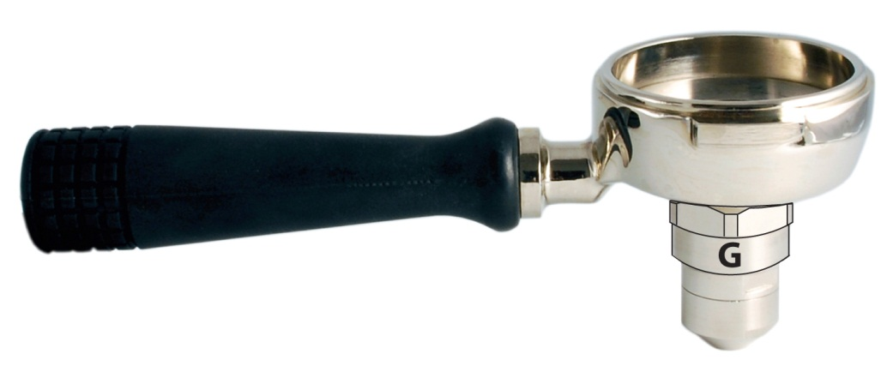
Cleaning and General Maintenance of Pod Handle.

- Place a ¼ teaspoon of a good quality espresso cleaning powder (e.g. Clean Express) in the filter basket of the group handle ( do not disassemble).
- Activate group and run for around 4-5 seconds. Repeat this process until the water runs clear from the handle allowing 5 seconds between each cycle.
- Rinse handle thoroughly and repeat process without cleaning powder in handle.
- Before the next use of the handle or group, ensure first coffee is disposed of.

If you find a build up of coffee residue within the edge of the filter basket (inside the handle – soak the handle in a teaspoon of espresso cleaning powder & hot water for 10 minutes & repeat step 2 to rinse.

